**Part A. Multiple choices**

1. Which of the following prints out floating-point numeric?
   1. int x = 10;  
      int b = 22;  
      System.out.println(x / b);
   2. int x = 10;  
      int b = 22;  
      System.out.println(b / x);
   3. float x = 10;  
      int b = 20;  
      System.out.println((int) x / b);
   4. float x = 10;  
      int b = 20;  
      System.out.println(b / (int) x);
   5. float x = (int) 10.00;  
      float b = (int) 22.00;  
      System.out.println(b / x);
2. Given Scanner sc = new Scanner(System.in) , which is the correct way to input an integer?
   1. int a = sc.nextFloat();
   2. int a = (int) sc.nextFloat();
   3. int a = (int) sc.next();
   4. int a = (int) sc.nextLine();
   5. None of the above
3. Given String s = “Java Programming”, choose all that print JAVAing
   1. System.out.println(s.substring(0, 4));
   2. System.out.println(s.substring(0, 4).toUpperCase().concat(s.substring(13)));
   3. System.out.println(s.substring(0, 4).concat(s.substring(13).toUpperCase()));
   4. System.out.println(s.substring(0, 4).toUpperCase() + s.substring(13).toLowerCase());
   5. System.out.println(“JAVAing”);
4. Which is variable assignment?
   1. int a = 10;
   2. int a = “Hello, world”;
   3. float a;
   4. a = “Good afternoon”;
   5. None of the above
5. 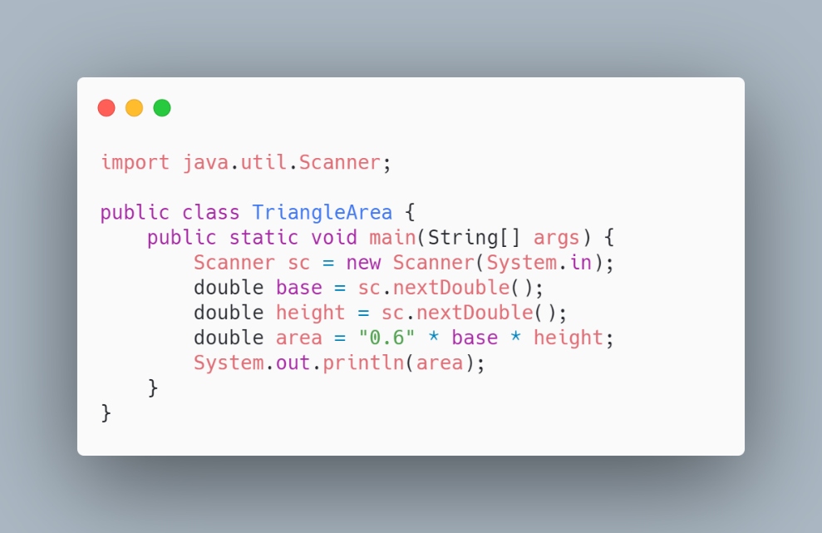In the program for calculating area of triangle below, what type of error will be found (if any)?
   1. Compile-time error
   2. Run-time error
   3. Logical error
   4. No error
6. Does Java use compiler or interpreter?
   1. Java uses compiler to compile source code into executable file.
   2. Java uses interpreter to interpret each line of source code.
   3. Java uses compiler to compile source code into bytecode, then uses interpreter to interpret the bytecode.
   4. Java uses interpreter to interpret source code into bytecode, then uses compiler to compile the bytecode into executable file.
   5. None of the above
7. Which of the following is an invalid variable name?
   1. _hello_world_
   2. $$$M0n3Y$$$can_not$$$buy$$$y0u$$$_HAPPINESS$$$
   3. rosesareredvioletsarebluelovenevercrossedmyminduntilthedayimetyou
   4. 1plus1_equals_1
   5. All of the above
8. Which of the following equals 6?
   1. 2 + 4 % 3 + 1 - 2
   2. 6 * 6 % 6 + 6 / 6 – 6 / 6
   3. 1 + 2 – 3 + 4 – 5 + 6 + 7 % 6 % 9
   4. 9 + 9 * 2 – 1 % 6 % 7
   5. 4 – 5 * 9 % 6 – 7 + 25 % 8
9. Given int a = 2, b= 1 , choose all of the following that equal 9
   1. a++ * (b+1) + b++
   2. ++a + ++a + ++b + b++
   3. b++ + a++ + b++ + ++a
   4. a-- - --a + b++ + ++b – (a-- - 3)
   5. (((b++)*b++)*b++) + b++ - --a
10. If we want to store 11-digit student ID , which data type should we use?
    1. int
    2. float
    3. double
    4. string
    5. long
11. If we want to change the string Hakuna Matata into Hikuni Mititi, which string method should we use?
    1. substring
    2. concat
    3. indexOf
    4. charAt
    5. replace
12. 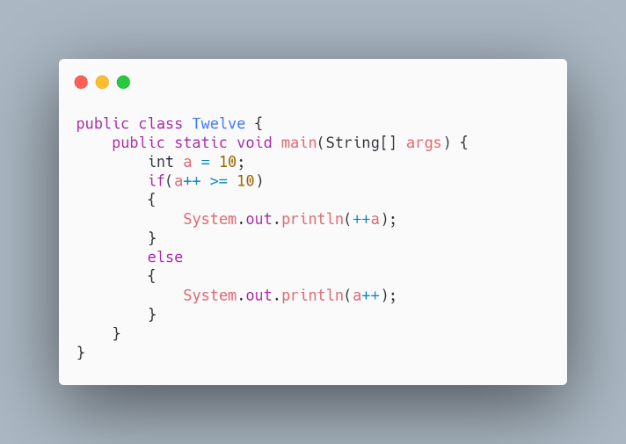 What will be the result of the following program?
    1. 8 b. 9 c. 10 d. 11 e. 12
13. What is the result of the following program?

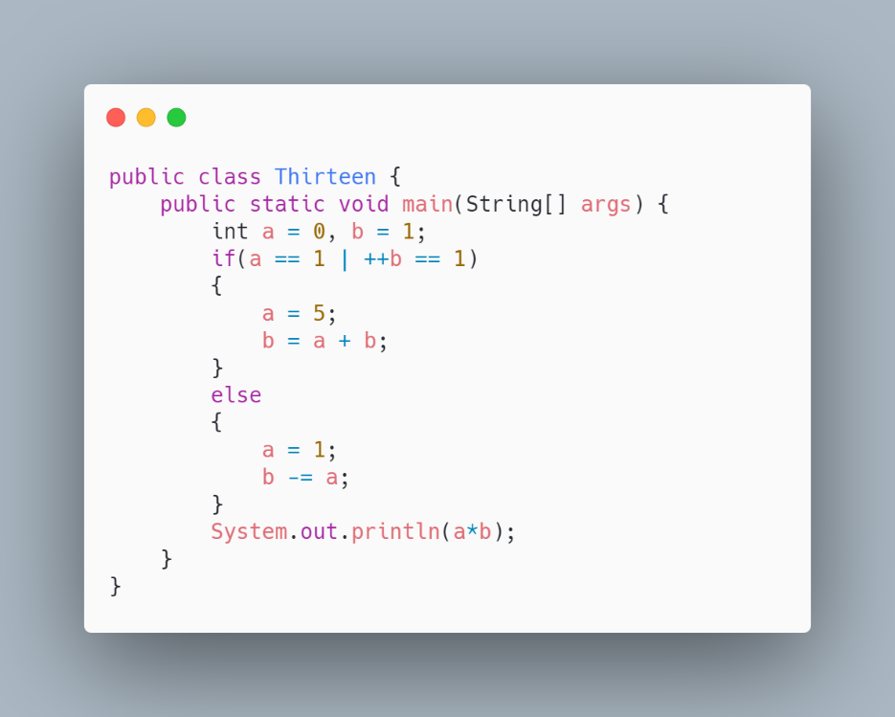

* 1. -1
  2. 0
  3. 1
  4. 2
  5. 3

1. What is the result of statement a = (b>10) ? 100 : 1; , when b = 20?
   1. 1
   2. 11
   3. 100
   4. 101
   5. 1001
2. Given String a = “Apple”, b = “Cat” , what is the result of statement a.compareTo(b)?
   1. -2
   2. -1
   3. 0
   4. 1
   5. 2
3. Given String a = “Cat”, b = “Catfish” , what is the result of statement a.compareTo(b)?
   1. -1
   2. -2
   3. -3
   4. -4
4. 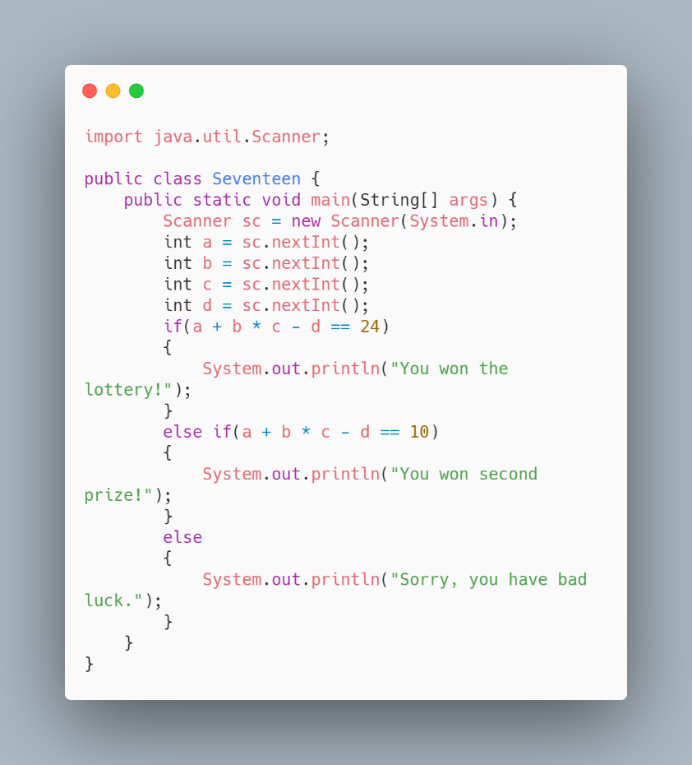In the program below, which input would give the output You won second prize!?
   1. 1 2 3 4
   2. 5 5 2 5
   3. 6 5 4 2
   4. 2 2 3 1
   5. -1 -2 -5 3
5. Suppose you write the code to display *"Cannot get a driver's license" if age is less than 18 and*

*"Can get a driver's license" if age is greater than or equal to 18*. Which of the following code is the best?

* 1. if (age < 18)

System.out.println("Cannot get a driver's license");

if (age >= 18)

System.out.println("Can get a driver's license");

* 1. if (age < 18)

System.out.println("Cannot get a driver's license");

else

System.out.println("Can get a driver's license");

* 1. if (age < 18)

System.out.println("Cannot get a driver's license");

else if (age >= 18)

System.out.println("Can get a driver's license");

* 1. if (age < 18)

System.out.println("Cannot get a driver's license");

else if (age > 18)

System.out.println("Can get a driver's license");

else if (age == 18)

System.out.println("Can get a driver's license");

1. 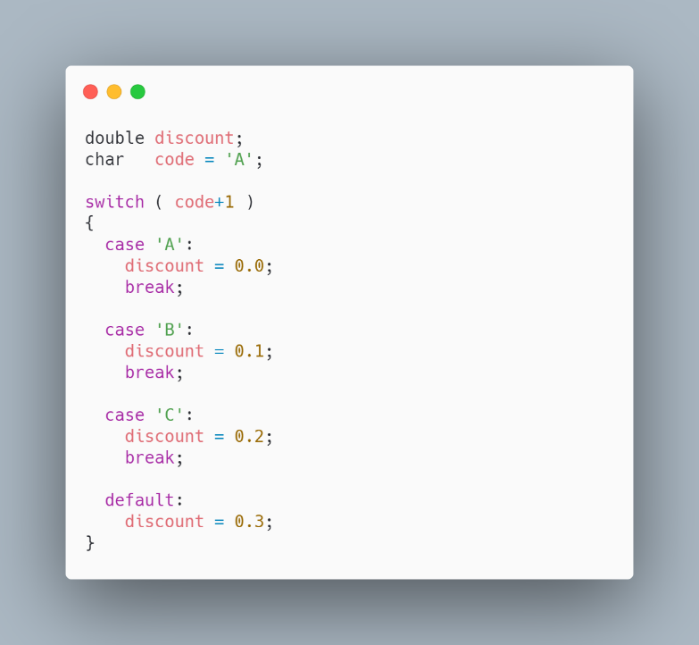What value will be assigned to discount?
   1. -0.1
   2. 0.0
   3. 0.1
   4. 0.2
   5. 0.3
2. What is the result?

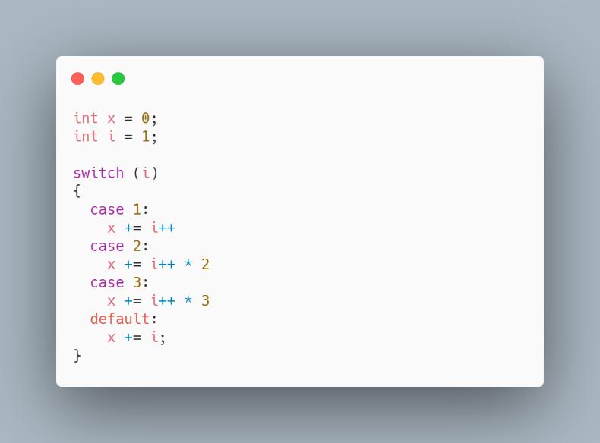

* 1. 1 b. 2 c. 3 d. 6 e. 18

**Part B. (Algorithm)**

**Write the output of each program.**

1. Input x = 6

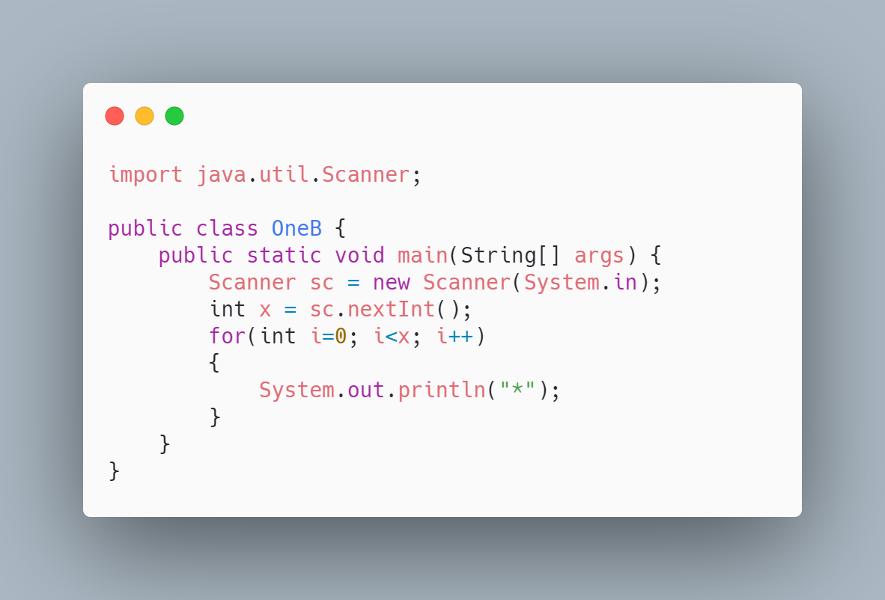

1. Input x=5

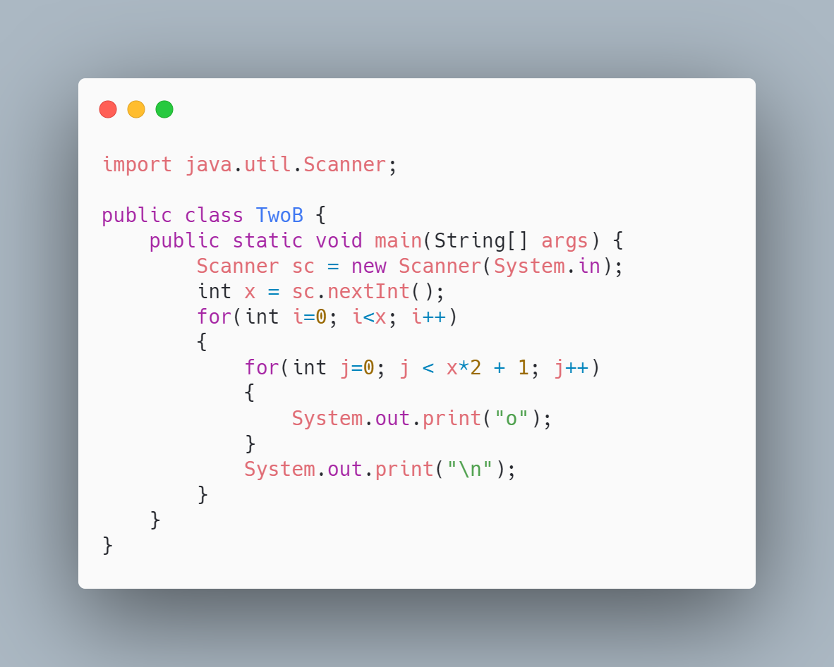

1. Input x = 4

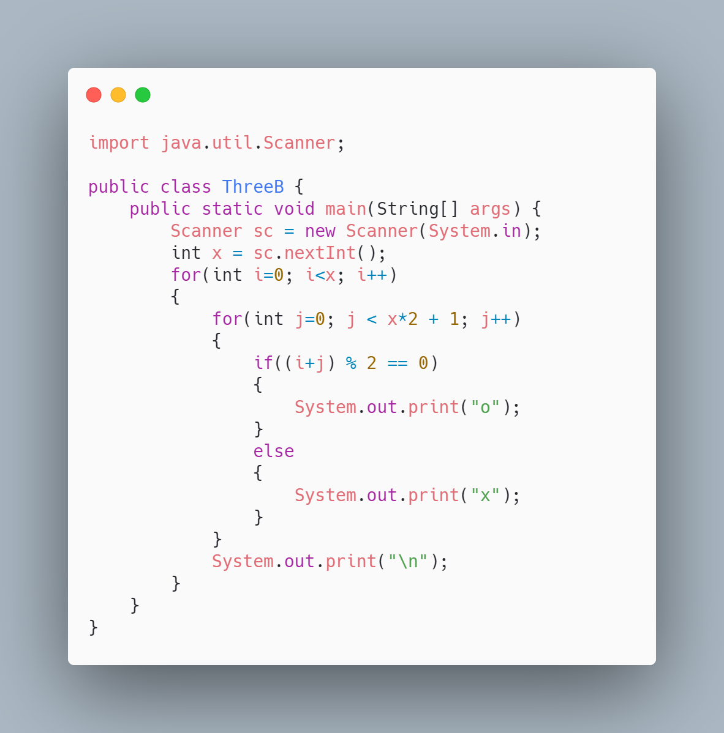

1. 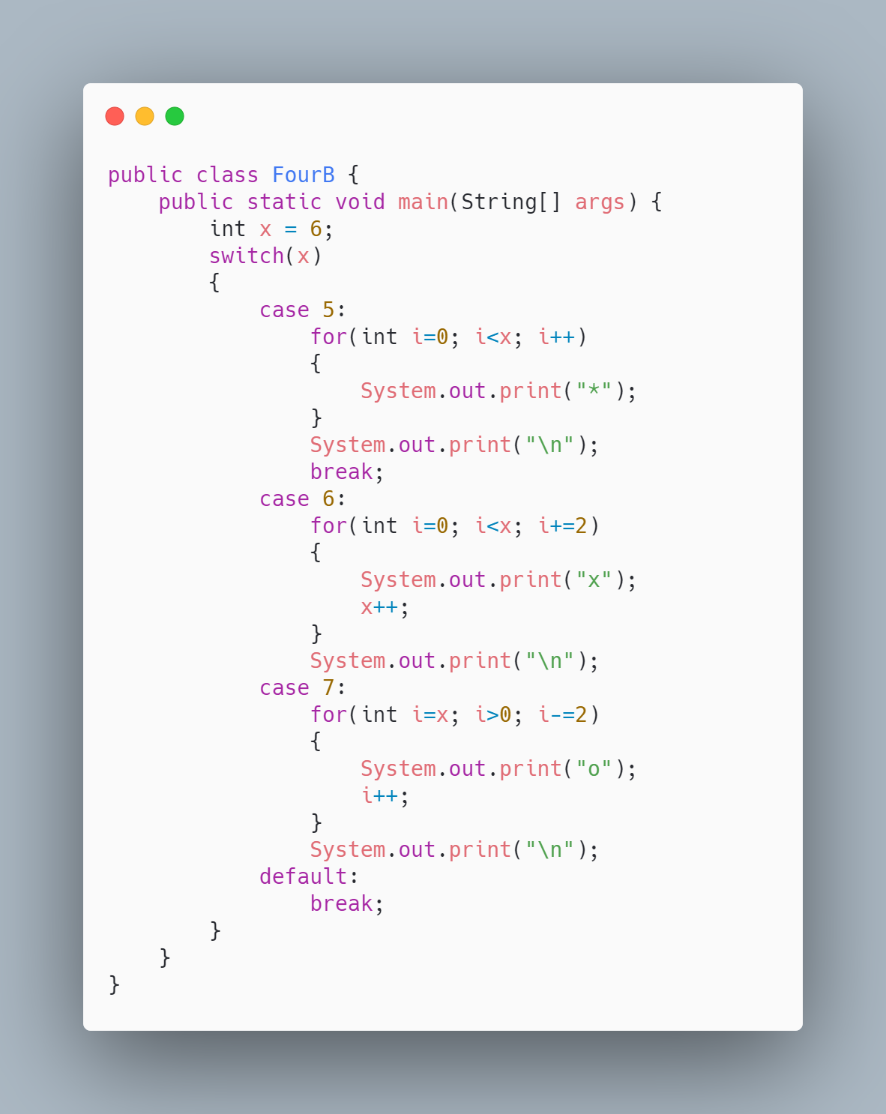
2. 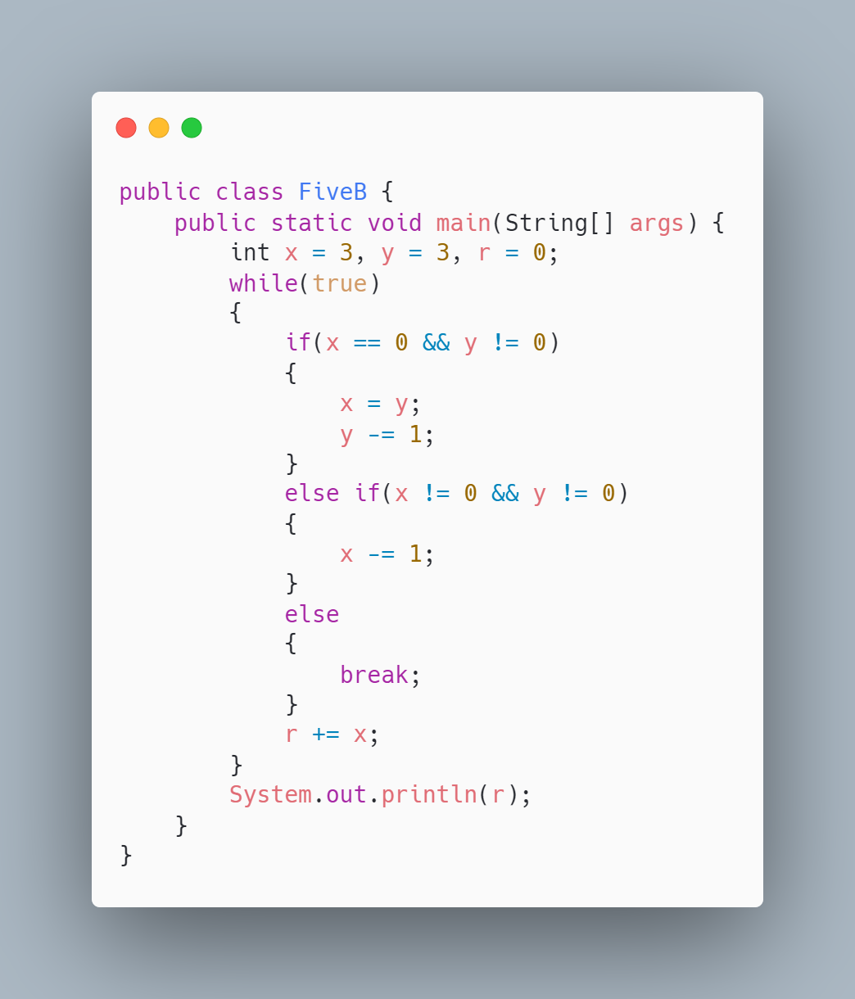d
3. 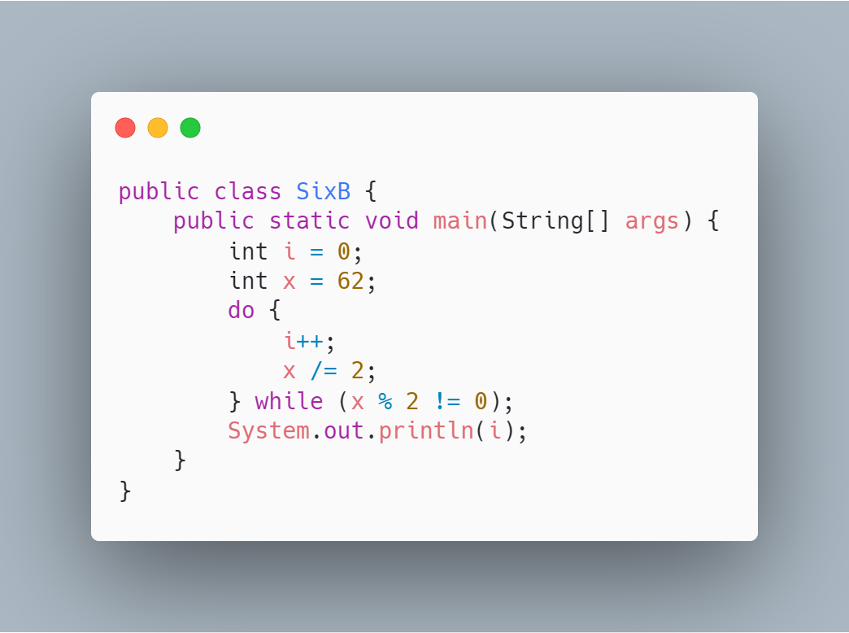
4. 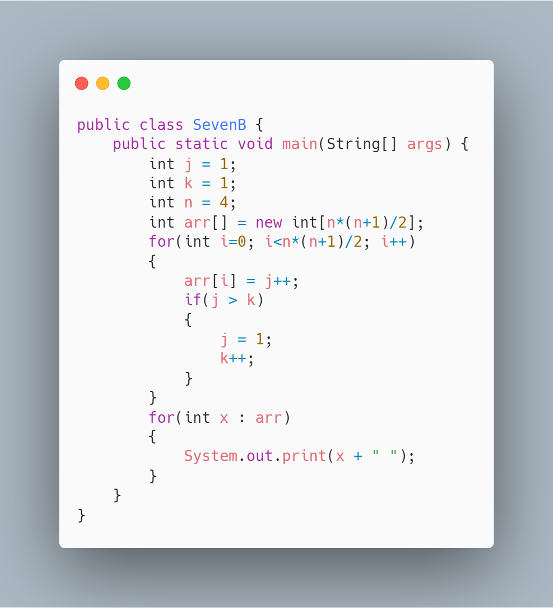
5. 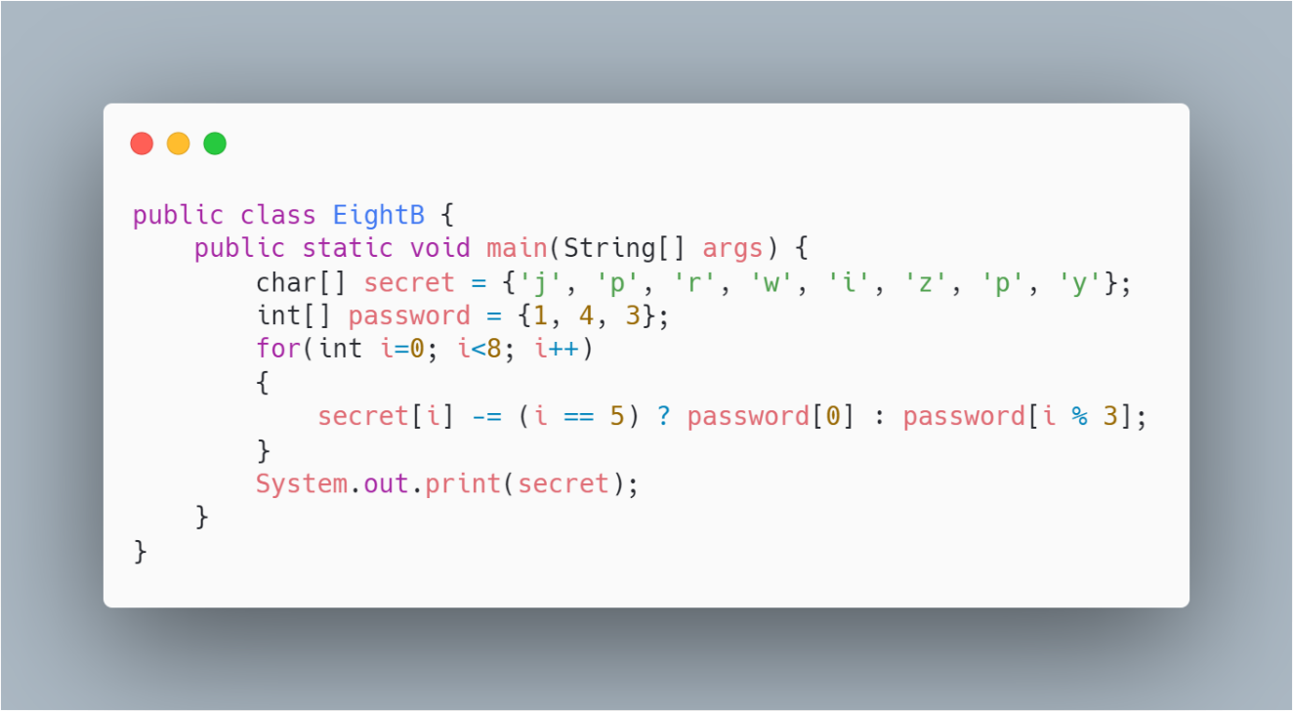
6. 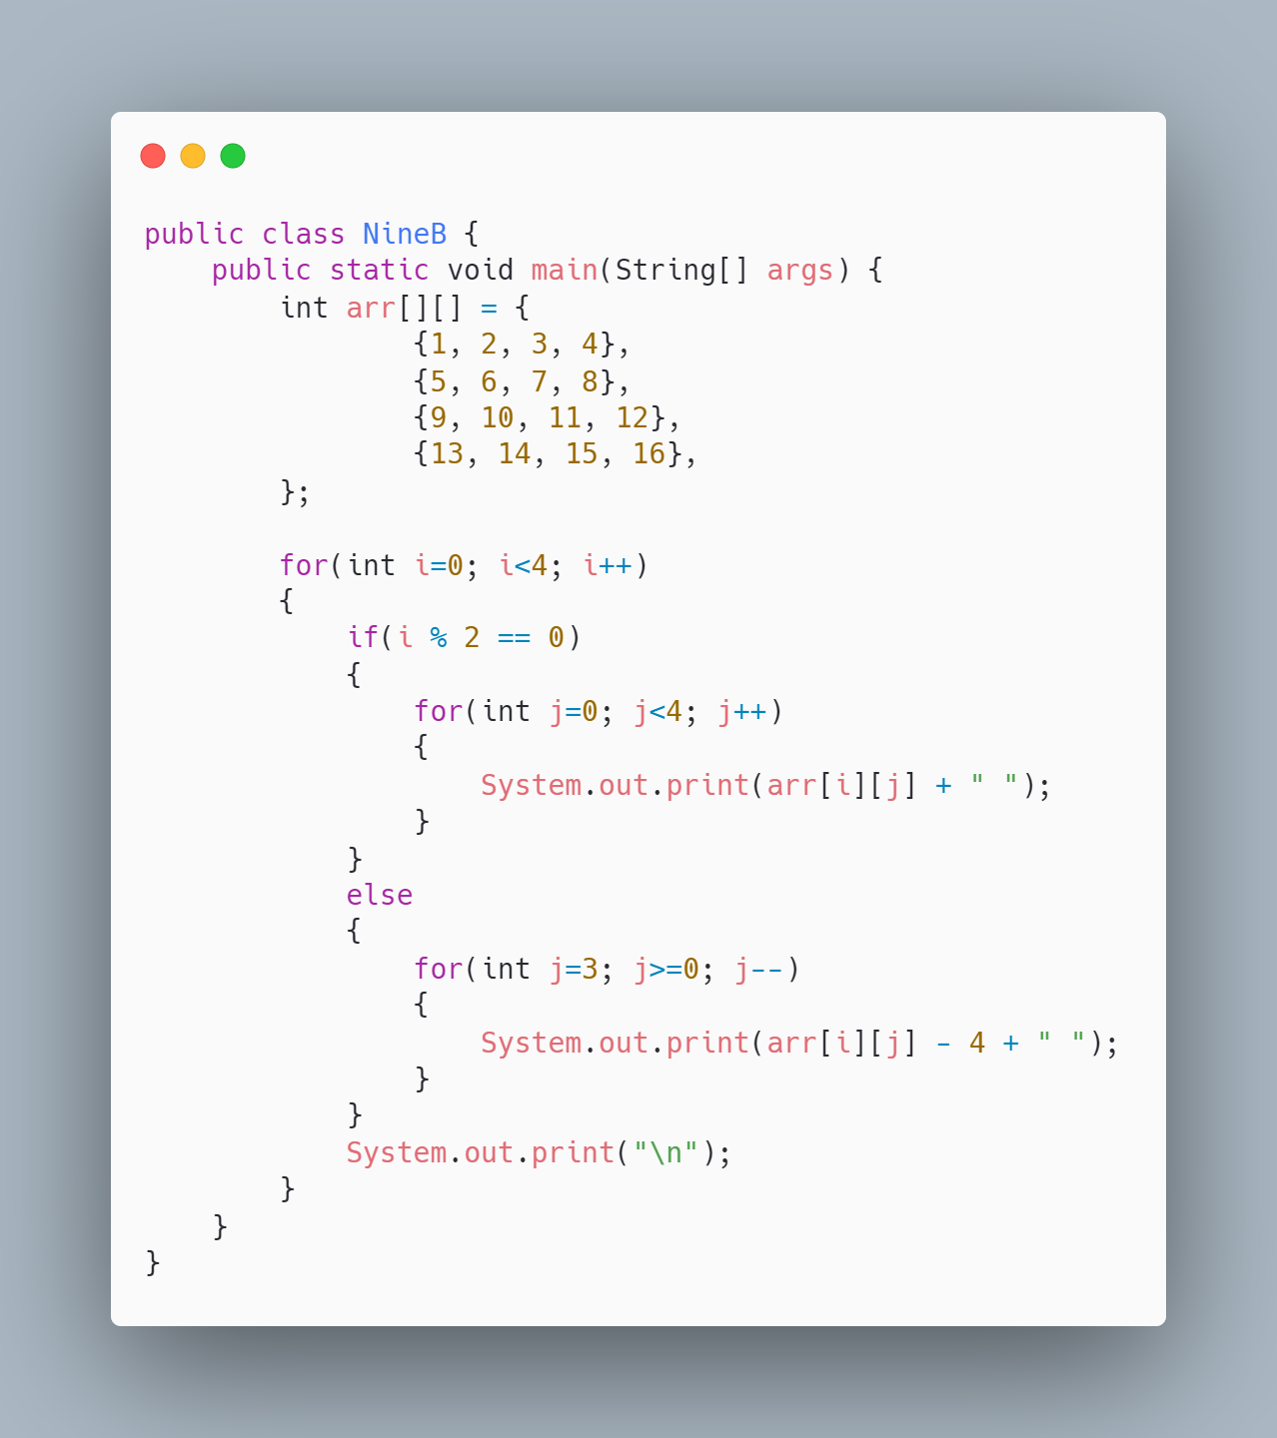
7. 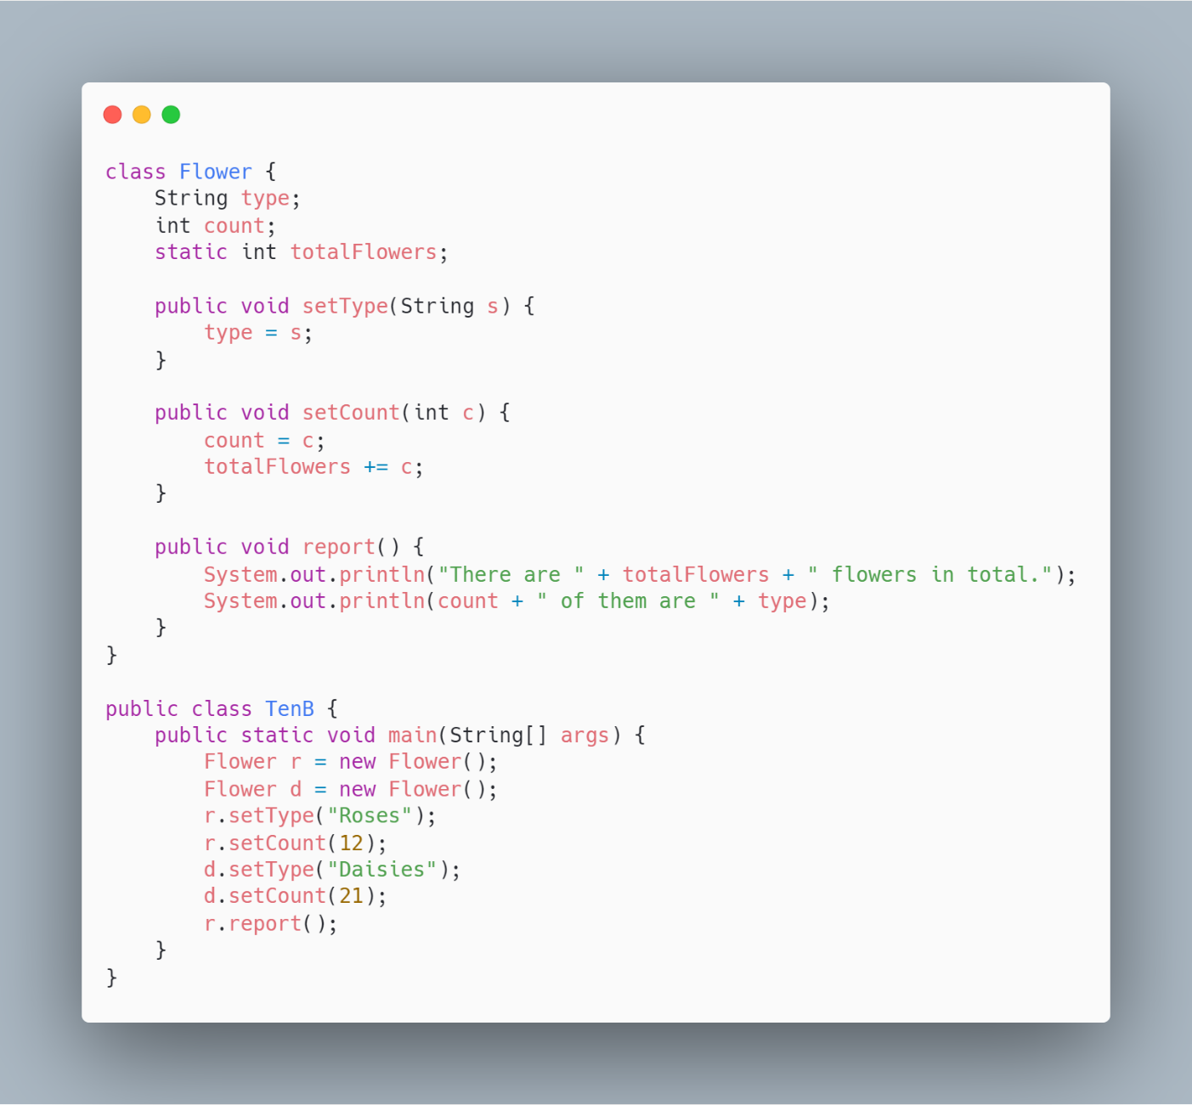

**Answer key**

*Part A*

1. E
2. B
3. BDE
4. D
5. A
6. C
7. D
8. C
9. CDE
10. D
11. E
12. E
13. C
14. C
15. A
16. D
17. B
18. B
19. C
20. E

*Part B*

1.

*

*

*

*

*

*

2.

ooooooooooo

ooooooooooo

ooooooooooo

ooooooooooo

ooooooooooo

3.

oxoxoxoxo

oxoxoxoxo

oxoxoxoxo

oxoxoxoxo

4.

xxxxxx

oooooooooooo

5. 13

6. 6

7. 1 1 2 1 2 3 1 2 3 4

8. iloveyou

9.

1 2 3 4

4 3 2 1

9 10 11 12

12 11 10 9

There are 33 flowers in total.

12 of them are Roses

10.

*Part C*